In 1963, Mary Kay started a new skin care business in Dallas, Texas with $5,000 and a big dream. She had worked in sales for other companies but wanted to design one of her own using the best practices she could think of. She wanted a product that would work so well that women would reorder it. She wanted to treat her sales force with positive training, recognition, and prizes women really like. She once won a fishing “flounder light” for being the top sales person in another company and vowed that she would give her sales force things like beautiful jewelry, trips, and pink Cadillacs—and she did.

That was 50 years ago, and what a 50 years it has been! Her little company of friends and relatives has grown so big that it is now in 35 countries and has over 2,000,000 consultants worldwide. In July, we will be celebrating the Golden Anniversary of the company in Dallas. It’s time for a “Sale-a-Bration!”

Buy $50 in products (regular retail prices) and pick out any product for 50% off.
Buy $100 in products and pick out any 2 products for 50% off.
Buy $150 in products and pick out any 3 products for 50% off.
Buy $200 in products and pick out any 4 products for 50%
(Yes, you may go higher and get more!)
Oh, and it’s okay if your ½ price product is an expensive one but skin care sets do not qualify. Each part of a set may count as a ½ price purchase item.

There are 6 exceptions on sets: the TimeWise Travel set may be a ½ price item. Other sets that may be ½ price items are the Microdermabrasion, Eye Color Bundles, Satin Hands Pampering Sets, the Brush Collection,
and the new Men’s Fragrance Travel Collection (perfect for Father’s Day).

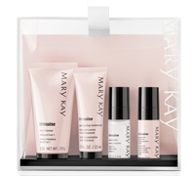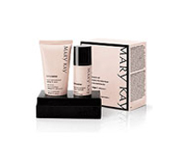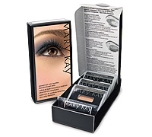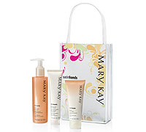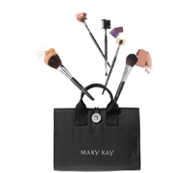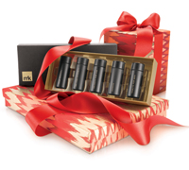

To order:
Call me at 218-556-8770 (cell).
Email me at jsiegert@hotmail.com
Order online 24/7 through my Mary Kay website at www.marykay.com/jsiegert
Visa, MasterCard, Discover, and American Express accepted.
Sale ends June 30, 2013
but if you order by June 10 you will receive a free hand cream.

