TimeWise Microdermabrasion Set
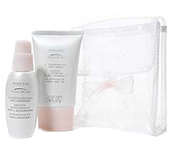
Non-comedogenic
Clinically tested for skin irritancy and allergy
Dermatologist-Tested
Suitable for Sensitive Skin
Oil and Fragrance-Free
For Dry to Oily Skin
Immediately fight fine lines, refine pores and achieve beautifully smooth skin with this two-step TimeWise® Microdermabrasion Set.
Step 1: Refine is a super exfoliator containing the same professional-grade aluminum oxide crystals used by dermatologists. These microfine crystals polish and gently remove the upper, dead layer of dull and lifeless skin cells to immediately energize skin and reveal more radiant, healthy-looking skin. This process immediately improves skin’s smoothness and clarity and leaves it feeling firm and softer.
Application: After cleansing, apply a quarter-sized amount of Step 1: Refine to wet face with fingertips. Using circular motions, gently massage face with fingertips for 1-2 minutes. Rinse thoroughly with warm water and pat dry. Follow with Step 2: Replenish.
Key Ingredients in Step 1: Refine
Aluminum oxide crystals work as a scrubbing agent.
Emollients and humectants aid in the application, slip and feel of the product.
Surfactants facilitate product removal.
Glycerin helps hydrate the skin, enhancing the efficacy of the aluminum oxide crystals.
Step 2: Replenish is a nourishing serum immediately absorbed by the skin to instantly smooth, soothe and soften the skin. Vitamins and powerful anti-oxidants nourish the skin and help protect against the environment.
Application: Following Step 1: Refine, use fingertips to gently apply Step 2: Replenish. Continue with TimeWise® Day Solution With Sunscreen SPF 15* or TimeWise® Night Solution and then TimeWise® Age-Fighting Moisturizer.
Key Ingredients in Step 2: Replenish
Triple tea complex works as an anti-irritant and antioxidant.
Vitamin C and a vitamin E derivative also work as antioxidants.
Emollients and humectants aid in the application, slip and feel of the product.
Timeron provides a pearlescent appearance.
Boron nitride enhances skin smoothness and facilitates a rapid dry down.
When used together, test results show after one week of use:**
- 85% saw an improvement in skin texture.
- 73% saw a reduction in fine lines.
- 71% saw pores that looked smaller.
* | Over-the-counter drug product
** | In a consumer study conducted by an independent research facility

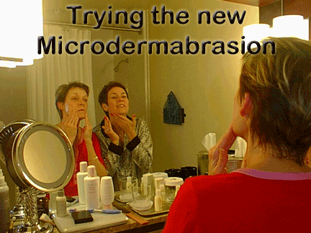
Script:
"What would you say if I told you that I had a product that could give you younger looking skin in just five treatments? Would you be excited?
How about in just three treatments?
What if I had a product that could give you younger looking skin in just one treatment? Would you be excited then?
Well, it's called Microdermabrasion and will be part of our regular product line starting 3/16! Let's get together today so I can show you how to prepared to maximize your benefits!"
Script:
Warning: This script can lead to pre-selling 10 Microdermabrasion Sets in 2 1/2 hours!
Must be read with ENTHUSIASM!!!
"Hi____this is _____with Mary Kay, do you have a quick minute? I am so excited to share with you a revolutionary product that we are coming out with in March! It is cutting edge and all the rage! It is our Microdermabrasion Set. Do you know what microdermabrasion is? (Pause) Up until recently, you could only receive this treatment at a dermatologist office and it wasn't cheap! Our treatment is designed to refine and replenish your skin making it look and feel younger in two easy steps. The first step is an Aluminum Oxide that gently refines the skin. The second step is a serum that contains vitamins and anti-oxidants to replenish the skin. No other product like our second step is on the market. You will experience a deep clean like never before and our directors who have tried it say they could see results in ONE treatment! I can get excited about that, can you?! Ok, this product will sell out fast, so I am taking pre-orders tonight. The set retails for $55, but tonight I am offering a special, your cost including tax is $50. Remember, this same treatment at your spa or dermatologist's office will be between $75-$200 ... and that's a SINGLE TREATMENT!! They recommend a series of 4-6!!! Yours is a 2-3 month supply!!! Is there any reason why I can't put you down for one?"
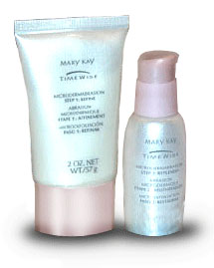
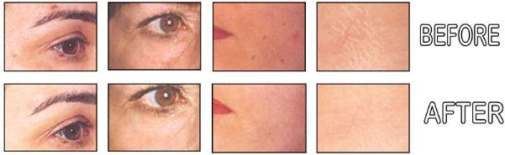
Can you say, RESULTS!!!
For an excellent flier by Pat Ringnalda showing what it is, how it works, and who should and shouldn't be using it CLICK HERE
Click Below for more Info
Microdemabrasion FAQs
Order of Application
Price Comparison
Test Panel (Thank you Pat Ringnalda)
Party Invitations (Thank you Donna Bayes)
MICRODERM
WARM CHATTER SCRIPT
Thank you Leigh Ann Bender for this Great Script!!!
Warm Chatter
Excuse me miss, you are just so sharp and you probably think I am crazy but I am a Sales Director with Mary Kay and I have to get the opinion of 30 women today on our new microdermabrasion product. You just look so sharp that I had to stop you! Have you heard of microdermabrasion? Well it costs $75-$100 per session at the dermatologist’s office, so there are lots of at-home kits on the market now because it is so popular. (Give her the sample) All you have to do is take this cute little packet home and try it before you go to bed. The first step is a scrub that you use after you wash your face. Wet your face with water and massage the scrub in. Then wash it off. The second step is a serum that you put on your face and leave on to help the skin. Now if I could just get your name and number so I can call you tomorrow evening to do a quick 2 minute survey that would be great. Thanks so much for helping me, I really appreciate it!
Follow-Up
Hi Suzie! It’s Leigh Ann Bender, we met at the cosmetics counter at Burdine’s yesterday. Do you have a quick minute? I just wanted to go over the survey on the microdermabrasion product. Did you get to try the product yet?
a. Yes? Ok great then let’s get started, this won’t take but a minute
b. No? Oh it’s ok! Why don’t you try it tonight and I’ll try to back again tomorrow evening.
Survey
- Tell me how you used the product? (this is to make sure she used it properly by washing off step 1 and leaving on step 2)
- Did your face feel smooth and clean afterwards?
- Did you see a difference in your skin texture? Did your pores look smaller? Did you see your skin glow?
- Did you notice any redness after using Step 1?
  - No? Ok great! That’s wonderful.
  - You did? Well that’s very common since your skin is getting a very deep cleaning. Did the irritation go away after using Step 2? Great!
- Now Suzie, our product retails for $55 per set and that gives you about 45 uses. Do you think this is a reasonable price?
Closing & Additional Booking
Thanks so much for your help, Suzie! You don’t know how much you have helped me! Listen, I also have to get 30 sharp women’s opinions on the rest of our skin care line that work together with the microdermabrasion. I would love for you to try the entire line. If you do this and get 2 of your friends to join us, I’ll give you that $55 microdermabrasion set for free! What works best for you, this week or next? Morning or evening?



